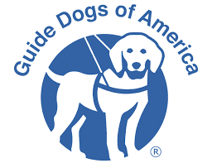1stAnnual Poker for Pups
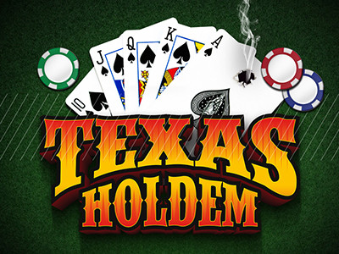
Proceeds will go to Guide Dogs of America
Saturday, April 13, 2019
Time: Registration begins at 2:00 pm and play begins at 3:00 pm

Where: THE OzSBI BUILDING
408 Washington Ave
West Plains, MO 65775

**FIRST PLACE PRIZE IS $1000.00**
(First Prize based on a minimum of 60 participants)
BASED ON THE NUMBER OF PARTICIPANTS
OTHER PRIZES TO BE DETERMINED THE NIGHT OF THE TOURNAMENT
Entry fee is $40.00 donation per player
$40.00 Re-buy first hour and half
Refreshments will be available for a small donation.
(No coolers or alcohol may be brought inside
________________________________________

Please remit sponsorships and /or advance seating requests to
I.A.M. Local 2782 Suite 134 OzSBI Building 408 WASHINGTON Ave West Plains MO 65775
All prepaid players are guaranteed a seat if he/she arrives prior to 2:50 pm. Maximum amount of players to be 120.
Direct any questions to 417-255-8798 or 417-247-5561.
Preregister & prepaid by April 10, 2019
And receive $500.00 additional chips

Name___________________________________________________________________________________

Address_________________________________________________________________________________

City________________________________State______________Zip_______________________________

_____ Straight Sponsor $100.00 _____ Flush Sponsor $200.00 ______ Royal Flush Sponsor $300.00

__________Advanced Seating @ $40.00 per person $___________

